**Course Registration & Activity Workbook**



**Welcome**

Welcome to the online Course Workbook.

To start the Course, click on or open the Course video link (Point 2 on Page 2).

To get the most out of the Course, we recommend you complete each activity in your Workbook when it is displayed on the video screen, as you go through the Course.

This Workbook supports the online Course video **and** sets out the Course Activities.

You can pause the Course video at any stage to have a break, think about issues and document your Course Activities responses.

One of the Course activities is the completion of a Risk and Value Driver Assessment (RAVDA). The RAVDA is an online questionnaire that will produce a Scorecard based on your responses. To access your ‘Risk & Value Driver Assessment’ click on or open the link displaying this title (Point 3 on Page 2).

Like all Course activities, completion is voluntary, and at no cost to you.

To make sure completing the Course is as simple as possible, we have listed the key steps and links you need, so that in the event you don’t complete the Course in one session, you can easily locate where you left off and continue.

1. **Registration**

For more information on the Course, open the Registration Video by clicking on the link below:

https://valuationimprovementcourse.com/courses/7bf1afcd-57a7-4624-99c5-93f46182e08862ce7a32-55ce-4e32-a623-f5b7e1f273a3

1. **Start the Course**

To start the Course, open the Course Video by clicking on the link below:

https://valuationimprovementcourse.com/courses/dde6846e-89c4-47b4-a4c3-b993e5eef5158bab895e-94f3-4646-abd7-dd6cec505717

1. **Risk & Value Driver Assessment**

To create and complete a Risk & Value Driver Assessment, click on the link below (use the Google Chrome browser). In the Course Video we explain how to do this.

https://valuationimprovementcourse.com/courses/bGl0ZXJhY3ljb3Vyc2UtMzU4MEFsbGlhbmNlUGFydG5lcg==

Throughout the Course you have the option to complete simple activities that support the learning outcomes.

Please read the disclaimer in the Workbook before starting the Course.

If you have any problems or need further support, contact us via the email address below:

ivan@divest.co.nz



**Activity 1**

**1.1 What is the main reason you decided to complete the Course?**

Response: __________________________________________________________  
______________________________________________________________________________________________________________________________________



**Activity 2**

**2.1 Do you know how businesses like yours are valued?**

O *Yes* O *No* O  *Unsure*

**2.2 How confident are you that your business value meets or exceeds your desired sale price expectations?**

O *Very confident*

O *Slightly*

O *Not confident*

O *I’m not sure what my business is worth*

**2.3 If you sold your business today, would the net sale proceeds be enough to fund your retirement lifestyle?**

O *Yes* O *No* O  *Unsure*





**Activity 3**

**3. Rank the learning outcomes from your highest (1) to lowest importance (5).**

( ) *Valuation Methods*

( ) *Performance Indicators*

( ) *Risks & Value Drivers*

( ) *Industry Benchmarks*

( ) *Financial Independence*



**Activity 4**

**4.1 Rate your level of understanding of each Method.**

|  |  |  |
| --- | --- | --- |
| **Asset Valuation** | **Discounted Cash Flow or NPV** | **Capitalisation of Profit** |
| O *High*  O *Medium*  O *Low* | O *High*  O *Medium*  O *Low* | O *High*  O *Medium*  O *Low* |

  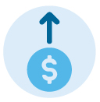

**4.2 Nominate which Method you believe best suits your business.**

Response: ___________________________________________________________



**Activity 5**

**5.1 In simple terms, if a business has Sustainable Profit of $350,000, a Business Capitalisation Rate of 3.25, what could its value be using the Capitalisation of Profit method?***(The correct answer appears on page 15)*

O *$1,050,000*

O *$1,137,500*

O *$1,475,000*

**5.2 How long will it take for you to create a Business Value Surplus?**

O *Don’t know*

O *Too long*

O *I need a plan*

O *I’m there now*

**Value Gap or Surplus?\***

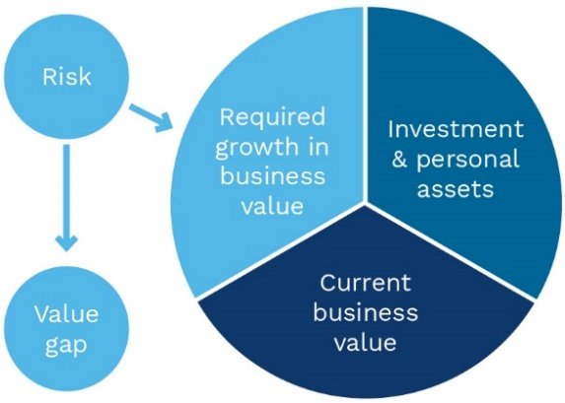

**\*Later we look at key ways to grow your business value, e.g., by increasing sustainable profit, improving cash flow, reducing risks and improving key value drivers.**



**Activity 6**

**6. Rank your level of understanding of each of the 3 key success factors:**

|  |  |  |
| --- | --- | --- |
| **Profit** | **Cash Flow** | **Risk & Value Drivers** |
| O *High*  O *Medium*  O *Low* | O *High*  O *Medium*  O *Low* | O *High*  O *Medium*  O *Low* |



**Activity 7**

**7.1 Do you understand the difference between Accounting & Sustainable Profit?**

O *Yes* O *No* O  *Unsure*

**7.2 How long has your business been generating Sustainable Profits?**

O *>10yrs* O *5 - 10yrs* O *0 - 5yrs* O *<0yrs*

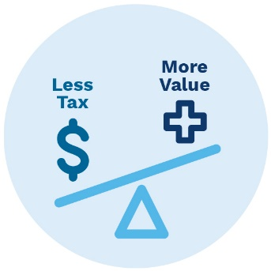

**7.3 List 1 item you believe could cause a difference between Accounting & Sustainable Profit.**

Response: ________________________________________________________



**Activity 8**

**8. If you paid yourself a commercial or market-based salary would this change your current Accounting Profit?**

O *Yes* O *No* O  *Unsure*



**Activity 9**

**9.1 Your Cash Flow is…….**

O *Very good* O  *Sporadic issues* O  *Continual headache*

**9.2 How do your business Debtors and/or Stock Turnover days compare to industry benchmarks?**

O *Excellent* O *OK* O *Poor* O *Don’t know* O *N/A*

**9.3 Can you produce accurate financial reports on a timely basis?**

O *Yes, ‘best practice’ reporting exists*

O *Systems need review/updating*

O *No, a major worry*



**Activity 10**

**10. Can you nominate one External Risk that has affected most businesses?**

Response: _________________________________________________________

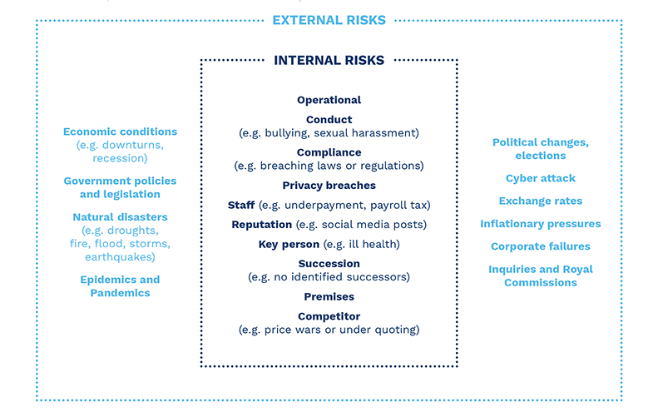



**Activity 11**

**11.1 Can you nominate another External or Internal Risk that has affected your business?**

Response: _______________________________________________________

**11.2 Do you have contingency plans in place to protect your business from any identified or potential External or Internal Risk/s?**

O *Yes*

O *No*

O  *Unsure*



**Activity 12**

**12.1 How much does your business rely on its owner(s)?**

O *None* O *Low* O *Medium* O *High* O *Very high*

**12.2 Does your business have an Operations Manual?**

O *In place*

O *Work in progress*

O *Not at all*

**Complete Your RAVDA**

*It’s now time to complete your Risk and Value Driver Assessment (****or RAVDA****). The RAVDA is an online questionnaire we use to help our clients minimise risks, drive performance, grow profit and maximise business value.*

*The RAVDA asks you questions about your knowledge of many non-financial aspects of your business and captures your comments. It also asks you to rate your level of concern about each issue.*

***The Course contains a video showing you how to set-up and complete the RAVDA.***

*To set-up and complete your RAVDA, go to Point 3 on Page 2 of the Course Registration & Activity Workbook and using the Google Chrome browser click on or open the Risk & Value Driver Assessment link.*

**Start your RAVDA**

*To start your RAVDA, you need to:*

* *Record a reference number that relates to your business;*
* *Nominate a contact email address;*
* *Enter your business’s most recent financial year total gross revenue, sales or trading income;*
* *Select the Industry or Niche Market your business operates in.*

*When selecting your Industry or Niche Market you will see a range of categories listed in 2 different drop-down menus. Please review each option to identify the most appropriate, general category for your business.*

*Once all this information has been entered, click on* ***Course RAVDA*** *(Step 5) and then select the* ***Start Course RAVDA*** *button. We recommend you pause the Course video at this point and take a note of the time. This will enable you to find the point of time to continue the Course.*

**Bookmark your RAVDA**

*As soon as you start your RAVDA a pop-up message will appear so you can bookmark your RAVDA. We recommend you do this before selecting* ***OK****, because if you partially complete and then exit your RAVDA, you can click on the bookmark to continue with your RAVDA.*

**Completing your RAVDA**

*When filling out the RAVDA it is very important that you:*

* *Answer* ***each question****;*
* *Rate your* ***degree of concern*** *for each question; and*
* *Record any* ***observations or comments*** *you wish to make.*

*You don’t need to answer the questions all at once. Your answers will be automatically saved, as you work through the questions.*

**Your RAVDA Scorecard**

*After completing your RAVDA, at the top right-hand corner of the RAVDA application, a ‘Submit Course RAVDA’ button will appear. Click on this to download your Scorecard and/or RAVDA.*

*Please download, save and store your RAVDA Scorecard in a place where you can access it easily.*

*When you return to the Course, we will go through a Scorecard. You should then access and analyse your personal RAVDA Scorecard.*

**Help Completing your RAVDA**

*If you have any problems completing your RAVDA, please select the ‘Help’ button.*



**Activity 13**

**13. Were you surprised by anything asked by the RAVDA? What was it, and why?**

Response: _________________________________________________________

**RAVDA Scorecard Analysis**

*Your RAVDA Scorecard uses data analytics to extract vital information highlighting opportunities to improve your business value.*

### **Your Score & Your Rating**

* *Your Score is expressed as the number of years an owner or investor is* ***prepared to wait*** *to get a total return of their funds invested in the business.*
* *Scores range from 1 – 12, a higher Score has a positive outcome on your business value.*
* *Your Rating is a statement of your RAVDA Score when compared to industry benchmarks.*

### **Your Risk & Value Driver Rating**

* *Your RAVDA rating values and rates the responses in each section of your RAVDA as Weak, Average or Strong.*
* *The opportunity is to address the sections in the RAVDA that are displayed as ‘Average’ or ‘Weak’ on your RAVDA Scorecard.*

### **Value Improvement Opportunity (VIO)**

* *Your VIO is the potential for growth in your* ***business value*** *if you improve your RAVDA Score, whilst all other factors remain the same.*
* *It highlights the improvement opportunity when compared to the industry standard and benchmark (top 20%) RAVDA Scores.*
* *Industry average profit and valuation benchmarks are used to calculate the values displayed in the bar charts.*

### **Track your Progress**

* *A changing RAVDA score is a concrete way to measure improvement in your business value.*
* *Your RAVDA can be updated each year as part an annual review of your business performance.*
* *As you implement your improvement strategies, the business changes are reflected in your RAVDA Score.*

### **Milestone**

* *Completing a Risk Diagnostic on your business using the RAVDA was* ***one of the key learning outcomes*** *of the Course.*
* *Generating your Scorecard is a* ***milestone achievement****.*



**Activity 14**

**14. How did your RAVDA Score compare to the industry benchmark?**

O *Above* O *On Par* O *Below*





**Activity 15**

**15.1 Have you benchmarked your business?**

O *Yes* O *No* O *Unsure*

**15.2 Do you think it is important an independent valuation is used for family succession planning?**

O *Essential* O *In some circumstances* O *Not at all*

**15.3 When buying a business, do you think it’s a good idea to:**

1. Access Industry Valuation Benchmarks to make sure you don’t pay too much for the business?

O *Definitely* O *All part of the mix* O *Not sure*

1. Know how you are going to grow the value before you buy the business?

O *It’s key*

O *Want to know upside/downside*

O  *Not sure*

**Industry Benchmarks**





ACTIVIY

15

**Activity 16**

**16.1 Do your financial accounts record your current business value?**

O *Yes* O *No* O *Unsure*

**16.2 Have you spoken to your Bank about specialised ‘Business Goodwill Funding’?**

O *Yes* O *No* O *I will now*

**16.3 How much does your current business value represent when compared to your total gross wealth management assets?**

O *>75%* O *25% - 75%* O *<25%* O *No value is recorded*

**16.4 If a trigger event (ill health, dispute, death) were to occur, is your current business value included in your asset protection & estate plans?**

O *Yes* O *No* O *Unsure*



**Financial Independence**



**Activity 17**

**17.1 Can you see the benefits of valuing your business now, rather than waiting for a time close to sale, exit or retirement?**

O  *Absolutely*

O *More informed*

O *Still need further information*

**17.2 Do you have a business plan that will create additional income, wealth and achieve your goals?**

O  *Yes*

O *Intending to develop a business plan*

O *Unsure*

O *No*



**Learning Outcomes Revisited**

|  |  |
| --- | --- |
| **1.** Do you appreciate the most appropriate **method** to value your business? | O *Yes* O *No* O  *Unsure* |
| **2.** Are you more aware of the **3 key success** **factors** that affect your business performance and value? | O *Yes* O *No* O  *Unsure* |
| **3.** Were you able to complete an **assessment** on your business Risk & Value Drivers using the RAVDA? | O *Yes* O *No* O  *Unsure* |
| **4.** Can you see the benefits derived from utilising industry **benchmarking** information? | O *Yes* O *No* O  *Unsure* |
| **5.** Will you take the first step towards ‘**financial independence**’ by valuing your business and establishing your current net worth position? | O *Yes* O *No* O  *Unsure* |



**Next Steps**

That’s it, we hope you enjoyed the online Course. You decide what comes next.

#### **Reflect……**

We recommend that you go back and reflect on the main reason you decided to complete the Course (**Activity 1**). Select an ‘end goal’ for yourself and consider making a formal plan for how to achieve it, with a timeline and milestones.

#### **Benchmark Report**

We will send you an Industry Valuation Benchmarks Report and then call you discuss the Learning Outcomes. If you need any further information, or would like to take action, we are happy to discuss any of the points covered in the Course with you.

#### **Feedback**

We also welcome and value your feedback. You can contact us by replying to the Course registration email. If you want to know more about our business valuation services, please include this in your email.

**Answer to Activity 5.1: $1,137,500**



Important Notices:

**General Information Only**

*The information in this Course (including the RAVDA) is of a general nature and does not purport to be complete, is provided solely for general information purposes and should not be relied upon by the viewer. No representation or warranty, express or implied, is made as to the fairness, accuracy, completeness or correctness of the information, opinions, case studies and conclusions contained in this presentation.*

*The RAVDA is an online questionnaire which can provide guidance on risks and issues relevant to individual businesses. It relies on input and responses by individual business owners and reflects the views of the respondent at one point in time. The RAVDA and RAVDA Scorecard can and will change as respondent input and answers change.*

*The Course (including the RAVDA) does not purport to summarise all information that a viewer should consider when making any decision, and should not form the basis of any decision by a viewer. Viewers should carry out their own investigations and analysis of issues relating to their business and verify the application of any strategy to their particular circumstances. The information in this Course (including the RAVDA) is subject to change without notice.*

*Before making any decision or taking any action you should make your own enquiries and investigations and consult your key business advisers. You should also seek legal, financial, tax and other advice appropriate to your jurisdiction.*

**No Liability**

*To the maximum extent permitted by law, each of the Principal, the Developer, each of their affiliates or related bodies corporate, their respective officers, directors, employees, agents or advisers (together, the Limited Parties) expressly disclaims any and all liability (including, without limitation, any liability arising out of fault or negligence) for any direct, indirect, consequential or contingent loss or damage arising from this Course (including the RAVDA) or reliance on information contained in or omitted from this Course (including the RAVDA).*

**Not Financial Product Advice**

*Reliance should not be placed on the information or opinions contained in this Course. This is not a financial product or investment advice or recommendation to acquire any product. The Course does not take into consideration the investment objectives, financial situation or particular needs of any particular viewer.*

This Course is offered to individuals by Divest Limited   (the Principal).

The Course and its content have been developed by Bstar Pty Ltd ABN 60 109 809 305 (Developer).

**Copyright**

*The copyright in this Course, the Workbook, the RAVDA, RAVDA Scorecard, related material and their contents are the property of the Developer and shall not be copied or reproduced in any manner whatsoever or distributed to others, whether in whole or in part at any time without the prior written consent of the Developer. The viewer shall keep permanently confidential the Course, the Workbook, the RAVDA, RAVDA Scorecard, related material and their contents and all information contained therein which is not already in the public domain.*